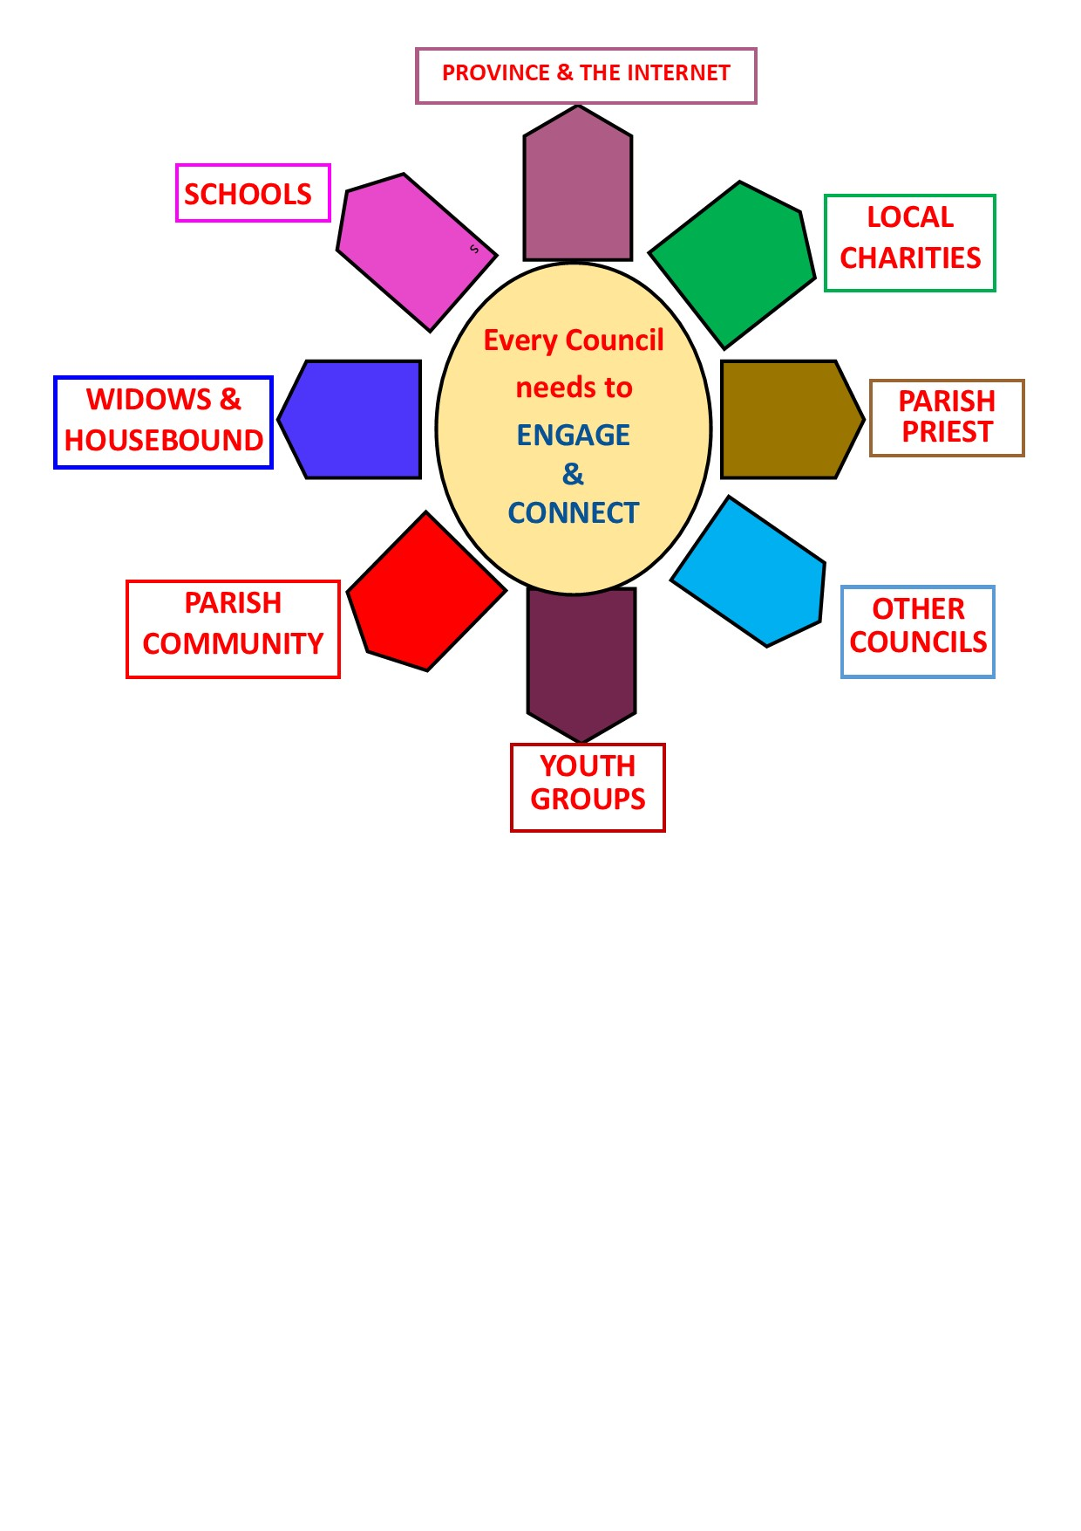
WHAT ACTION ?
Promoted by Head office.
A list of action items for discussion at your next council meeting to decide which is the most likely ACTION your council could be working on.
There is something for everyone…..
Click for itemised details of the various
Action proposals…… Click for more info…

Youth facebook page
Virtual Youth & Young people workshop
Cop26 Youth & Young people
Madonna Oakes Trophy
KSC Youth competitions
Things to do
Things to come

