Lyford Grange Mass 2018
For this years Mass, Fr John Chadwick , founder of the St Margaret Clitherow trust , is the main celebrant for the St Edmund Campion Pilgrimage Mass to be held at Lyford Grange, near Wantage on Sunday 24th June 2018 at 4.00pm. It was at the Grange that the Jesuit priest Edmund Campion was captured before being transported through the Thames Valley to London and put on trial. Campion was subsequently hanged, drawn and quartered with Alexander Briant and Ralph Sherwin on 1st December 1581.
St Margaret Clitherow is known and celebrated for her commitment to vulnerable and marginalised people in the sixteenth century and worked tirelessly to provide sanctuary, care and access to the sacraments for those who needed it. St Margaret, living in York, ultimately gave her life for the cause and is included with Edmund Campion, Alexander Briant and Ralph Sherwin in the forty English Martyrs canonised in December 1971 by Pope Paul VI th.
The location of Lyford (OX12 0EQ) is shown below:
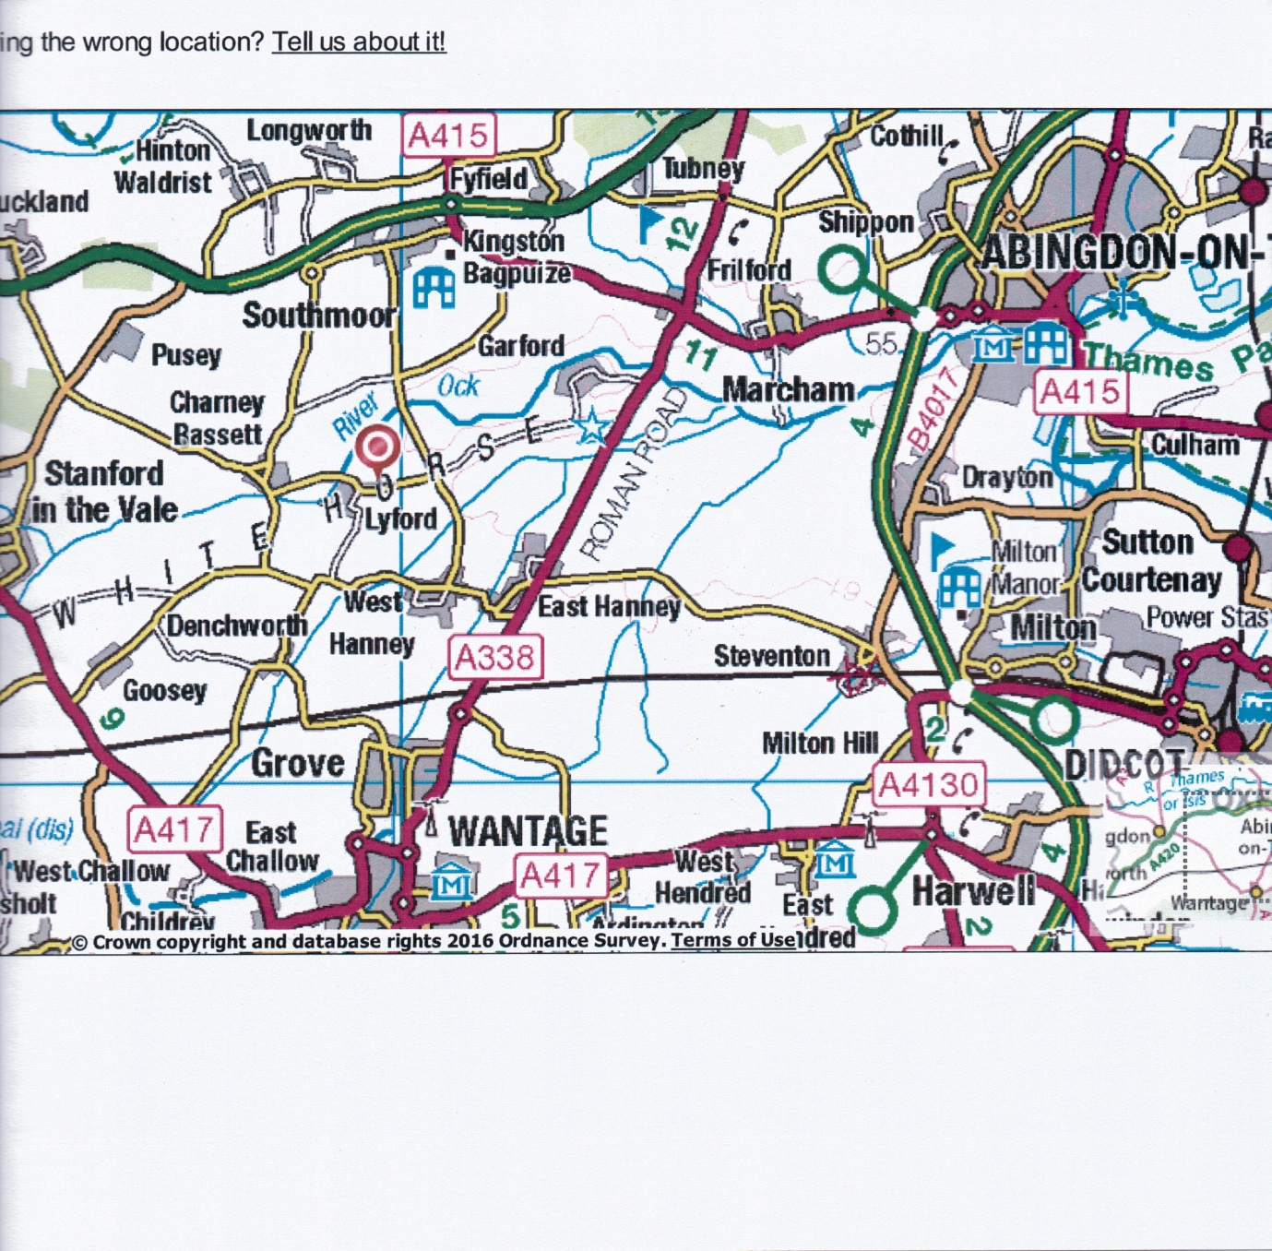
- The Lyford Grange Pilgrimage Mass is part of a sequence of daily Masses that nearly mirrors the route that Campion followed on his way to London. It includes Stonor (where Campion hid his printing press), Oxford where he was a scholar , Abingdon, Henley, High Wycombe, Maidenhead, Reading , Farnborough , Windsor , Staines and finishes with the Tyburn Convent Mass on Sunday 22nd July at the 4.00pm. Mass is celebrated at over 55 locations during the fifty one days of the pilgrimage.

The following photo’s show recent pilgrimages to Lyford and the five celebrants of the 2016 Mass comprising Bishop Philip Egan, Canon Peter Turbitt, Fr Dushon Croos, Mgr Andrew Burnham and Fr Jose Claveria
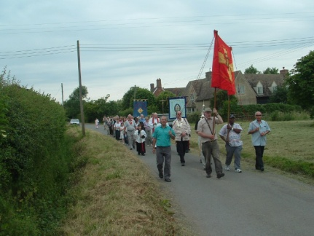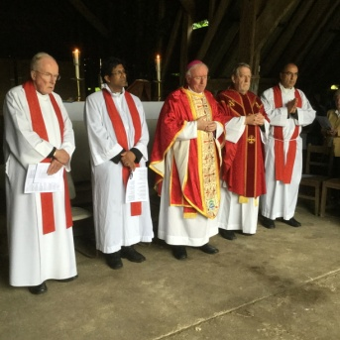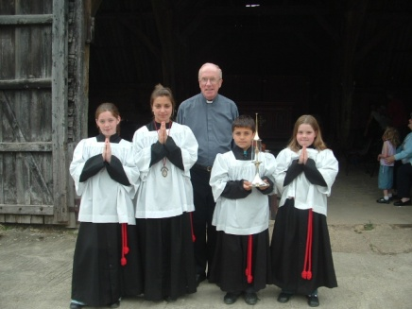

Further details of the pilgrimage can be found on www.province30.co.uk
* A more detailed account of the life and arrest of St Edmund Campion
* The history of the St Edmund Campion Pilgrimage is shown
* A full listing of visiting parishes/dates and Masses

For those pilgrims who would like to join this years Lyford Pilgrimage Mass it starts at the
Anglican Church of St Mary the Virgin in Lyford village at 3:30pm, the procession then proceeds to nearby Lyford Grange for Mass in the Barn at 4:00pm. Fr John Chadwick from St Joseph’s, Maidenhead will be accompanied by Fr Liam Cummins , PP of St Edmund Campion, Maidenhead along with Fr Kevin Jones and Canon Peter Turbitt and parishioners from St John Vianney, Wantage. There will be refreshments after the Mass.
Further details from John Lynn on Email johnlynn1@live.co.uk) or Tel 01628-636668

